[](http://tchnetwork.org/)

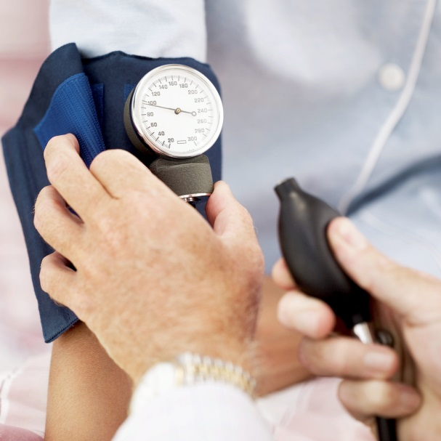

**Matters of the Heart**

A monthly newsletter about cardiovascular disease prevention and wellness promotion.

**Tri-County Health Network** is a nonprofit entity committed to improving the quality and coordination of health and healthcare services by increasing healthcare access and integrative health services at lower costs.

September 29th is World Heart Day

World Heart Day was founded in 2000 to teach people around the world about heart disease and stroke. Heart attack and stroke are the leading causes of death in the world today. Together they claim 17.3 million lives each year.

The focus of this event is to create a heart healthy environment by ensuring that everyone has the chance to make heart healthy choices wherever they live, work and play. Every year there is a different themed celebration to up awareness. This year the theme is creating heart-healthy environments. Facebook, Twitter, and all of the other social medias will be getting involved. Make a heart shape with your hands and post it on Facebook, or on Twitter using hashtag #heartchoices.

.

Ideas of some things you can do for this event:

* Dress in red to up awareness of the event.
* Join or start a team to walk for heart health.
* Get a heart health

screening

* Post a picture on social

media, making a heart with

your hands!

Do your part to keep

yourself, your friends,

and your family heart

healthy!

Don’t forget to post your Healthy Heart selfies! Take a picture of yourself making a heart symbol with your hands to help up the awareness. Get involved!

**Care for your heart and pay attention to signs and symptoms**

Your heart is the strongest and most important part of your health. But it also is very vulnerable to damage. This is why it’s important to know what signs to look for and to know how to take care of it.

Here’s a list of signs and symptoms to watch out for. If you have any of the following symptoms, please see your doctor to make sure there is nothing serious happening. If you think you may be having a heart attack, please seek emergency attention right away!

* Shortness of breath
* Irregular heart beat
* Fast heart rate
* Weakness and or dizziness
* Nausea and sweating
* Discomfort, pressure or heaviness in your chest
* Pain and or tingling in your arm
* Heartburn with difficulty breathing
* Extreme weakness or shortness of breath

Some things you can do to try to lower your risk of developing these symptoms.

* Exercise regularly (but don’t push yourself too hard, work up to it at your own pace. Work out smarter not harder)
* Laugh regularly (this is good for more than just your heart)
* Eat a healthy diet (eat lots of vegetables and try to lower your red meat intake. Eat fish instead when you can)
* Get regular heart screenings (check your blood pressure and cholesterol when needed)
* Talk with your doctor if medication is needed.
* Make sure to get plenty of sleep (REM sleep is required to heal your heart)

Spread the love and the knowledge!

**Beat This!**

**9 Amazing Facts about your heart.**

1. **Heart attacks are most common on December 25, 26 and January 1st. Keep your stress level low and pay attention to the signs. It could save a life!**
2. **The heart supplies blood to 75 trillion cells in your body. Your corneas are the only cells to not receive a supply of blood.**
3. **Your heart pumps 1.5 gallons of blood a minute.**
4. **A woman’s heart beats faster than a man’s heart by an average of 8 beats a minute.**
5. **The right side of your heart pumps blood into your lungs to get oxygen and the left side pumps it back into your body.**
6. **Heart disease is a very serious risk and is not new. Heart disease has been discovered in 3,000 year old mummies!**
7. **Your heart pumps enough blood in an average lifetime to fill more than 3 super tanker trucks.**
8. **People who work nights or swing shift are more likely to develop heart disease.**
9. **In an average lifetime, a human heart will beat more than 2.5 billion times!**

Heart Healthy Chicken Kebobs with Brown Rice

Tri-County Health Network

Main Office:  
PO Box 4222  
Telluride, CO 81435

Phone:

970.708.7096

Fax:

888.595.3242

E-Mail:

[*info@tchnetwork.org*](mailto:info@tchnetwork.org)

Web Site:

*Tchnetwork.org*

**Ingredients:**

1 lb boneless, skinless chicken

Breast

2 Tbsp low sodium soy sauce

20 oz canned unsweetened

Pineapple chunks can

1tsp minced garlic

Non-stick cooking spray

36 pineapple chunks, packed in

their own juice

2 fresh, bell peppers, chopped

into 36 pieces

1 pint grape or cherry tomatoes

12-15 wooden skewers

2 cups brown rice, cooked

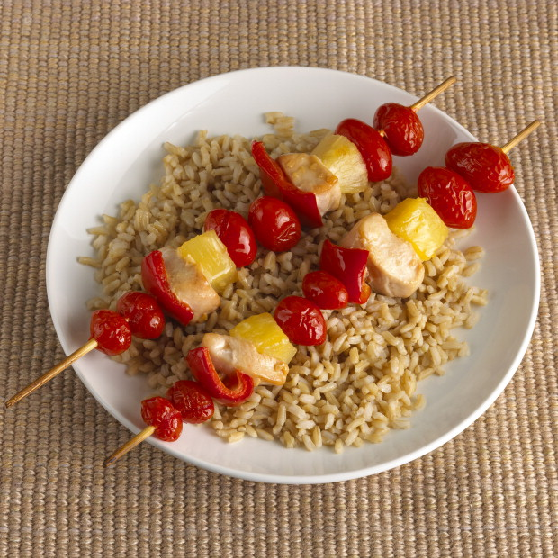

**Preparation:**

Cut chicken into bite size pieces. In a plastic zip lock bag (so nothing spills) add chicken, 1 cup pineapple juice and low sodium soy sauce.

Seal and let chicken marinate in the fridge for 15-20 minutes.

Soak kabob skewers in cold water for 10-15 minutes before using to prevent burning or fires.

**Nutritional Information**

**Per Serving**

Calories 306

Total Fat 4 g

Saturated Fat 0.5g

Trans Fat 0g

Polyunsaturated Fat 0.5g

Monounsaturated Fat 1g

Cholesterol 73 mg

Sodium 342 mg

Carbohydrates 40 g

Fiber 5g

Sugars 20 g

Protein 29g

This recipe and more nutrition information can be found at [**www.heart.org**](http://www.heart.org)

**Cooking directions**

1. Preheat oven to 400 ° F or warm up grill if you prefer. Take chicken out of fridge and pour into a bowl for easy access.

2. Spray a baking sheet with cooking spray. Assemble skewers with 3 pieces of chicken, pineapple, and bell pepper. Include other veggies if wanted.

3. Place on baking sheet (or grill) and cook until chicken is completely cooked (no pink inside) approximately 15 minutes.

4. Serve on a bed of brown rice

**Makes 4 servings**

**Summer Health Screening Schedule: Telluride, Ridgway & Ouray**

Take advantage of this opportunity for a free health screening!

Screening includes measurement of blood sugar, cholesterol, triglycerides, blood pressure, and body composition. **Learn your risk for heart disease!**

Ouray Public Health Agency, 302 Second Street, Ouray

Thursdays: 10:00am-4:00pm

July 9th, 16th, 23rd, 30th

August 6th, 13th, 20th, 27th

Ridgway Library, 300 Charles Street, Ridgway

Tuesdays: 10:30am-5:00pm

July 21st

August 18th

Wilkinson Library, 100 West Pacific Avenue, Telluride

Wednesdays: 10:30am-5:00pm

July 8th, 15th, 22nd,

August 5th, 12th, 19th, and 26th

**Appointments are strongly recommended to prevent waiting. Home and/or workplace visits can be scheduled at your convenience. If the dates and times listed above don’t work with your schedule, please call and we can discuss alternatives. Feel free to call, text, or email Nicole Gans, Community Health Worker at 970-318-6360 or** [**chw-ouray@tchnetwork.org**](mailto:chw-ouray@tchnetwork.org)**.**

**Don’t have time to do the entire screening?**

Feel free to stop by for a quick blood pressure reading or try out our new scale that

measures body composition (percentage of muscle and fat).

